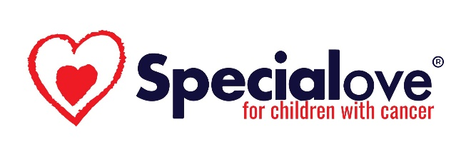
Eligibility Guidelines for Special Love Volunteers
The following are the requirements for everyone wishing to volunteer at an in-person Special Love event. Due to insurance regulations, all Special Love volunteers must be 18 years of age or older.
Covid Vaccination & Testing
- Must provide proof of Covid-19 vaccination (not required for virtual sessions hosted on Zoom) AND
- A negative Covid-19 rapid test taken within 24 hours of attending event.
Applications
- New volunteers at weekend events must provide a completed volunteer application.
- Camp Fantastic and BRASS Camp volunteers must (re)apply for a volunteer spot each year.
  - Campers ages 15-17 at Camp Fantastic (cancer patients/survivors) and BRASS Camp (cancer siblings) may be considered for leadership opportunities.
- Background checks are conducted annually on all volunteers.
  - Special Love reserves the right to refuse new volunteers or disqualify veteran volunteers based on information received on an updated background check.
Volunteer Families
- For Volunteers Related to a Camper:
Some of our volunteers get involved with Special Love because their family member is a camper. While we welcome all volunteers, particularly those whose family already has a history with us, a person may not volunteer at a camp or patient/sibling event where his or her family member is a camper.
- For Volunteers Not Related to a Camper:
Volunteers are not permitted to bring their family members to Special Love events. Our events are for Special Love patient family members only. This does not include fundraising events or any other ‘open to the public’ events sponsored by Special Love.
Wait Lists
- Volunteer spots will be available on a first-come, first-served and need basis
  - While Special Love would like to include every volunteer who wishes to come to an event, we must use our resources wisely and thoughtfully to keep the focus on the Special Love patient family.
- Volunteers may find themselves on a “waiting list” or unable to attend an event.
  - This is not necessarily a reflection on the volunteer, but rather a reflection on the needs of the program.

For more information about volunteering for Special Love, please contact Luke Child by emailing lchild@specialove.org or calling (888) 930-2707. Thank you!

